**Lab – 35: How to create a user to manage access in Intune?**

**Objective:** The objective of this lab is –

* To create a user to manage access in Intune.

Every person who is using company data will need a user to manage access to it in Intune. So, in this lab we are going to create a user who can manage access in Intune.

**Prerequisite:** EMS Enterprise Mobility + Security E5.

**Steps:**

1. Sign in to your Azure Portal, by using the link - **https://portal.azure.com/**. Enter your credentials and click Sign In.

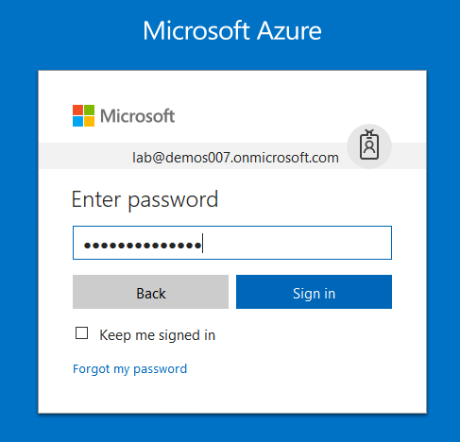

1. If it asks to stay signed in, then you can click Yes or No as per your choice to reduce the number of times you are asked to sign-in.
2. Microsoft Azure AD Dashboard will open.

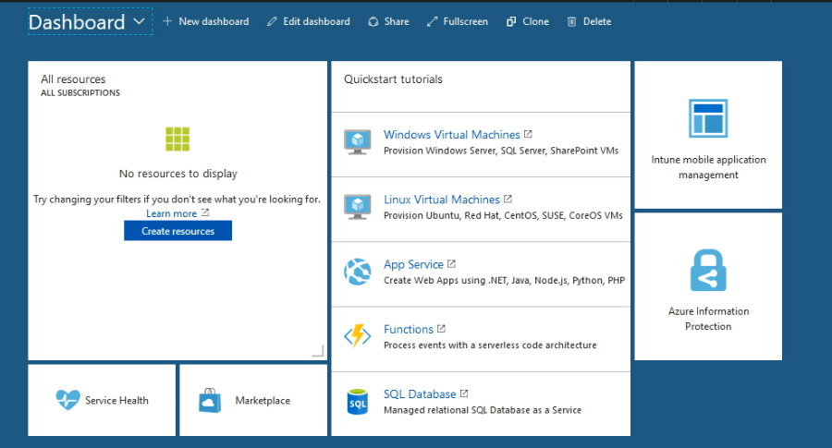

1. Open Microsoft Intune service from the left-hand side of the Azure portal.
2. Once you've opened the **Microsoft Intune** blade, select **Users**. On the All Users page, select **+ New user**.

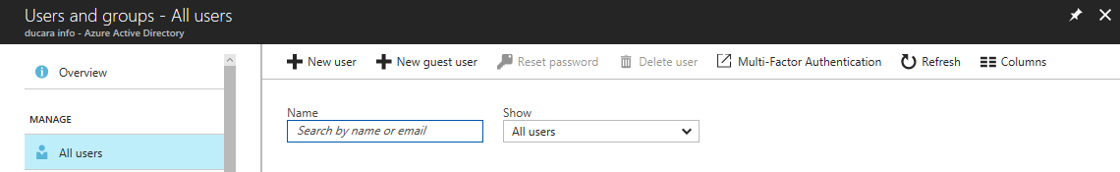

1. Enter details for the user, such as **Name** and **User name**. The domain name portion of the user name must either be the initial default domain name “contoso.onmicrosoft.com” domain name, or a verified, non-federated domain name such as “contoso.com.”

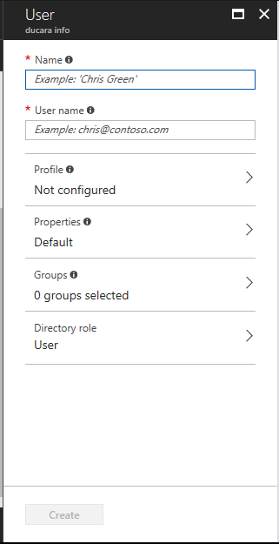

1. Click **Profile**, to enter complete profile details of a user like – First Name, Last Name and Work info. After entering click **OK**.

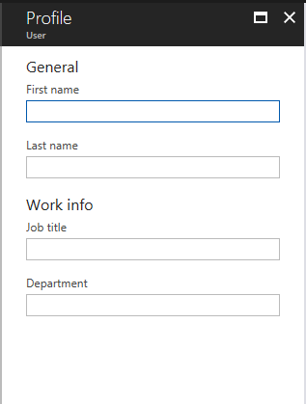

1. You need to ensure that the **Directory role** should be selected as User, because here we are creating a user.

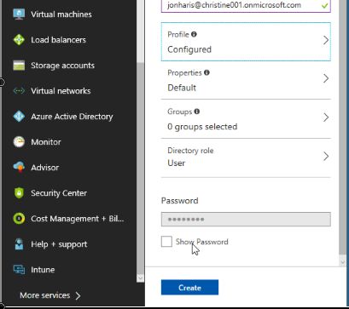

1. Save the automatically generated user password so that you can use it to log in to a device. You must give this password to users so that they can change it to a normal password that they can remember.
2. Then on the User blade, select **Create**.
3. Now you can see a notification message will pop-up of the **successfully created user** at the top right corner of the portal.

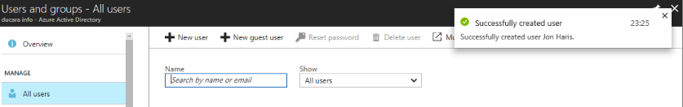

1. Also, you can check a new user is created in the list.



1. So, in this way you can create a user to manage access in Intune.